

2011 Core-to-Core Program Educational Work-Shop for Young Researchers

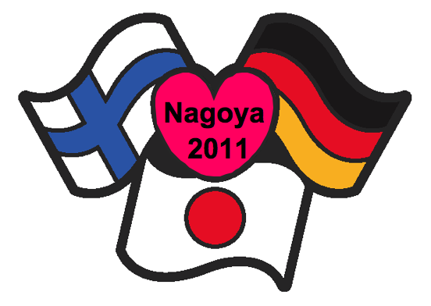

Monday, 10th October 2011
9:30-11:50

Nagoya international Congress center
Hall 7

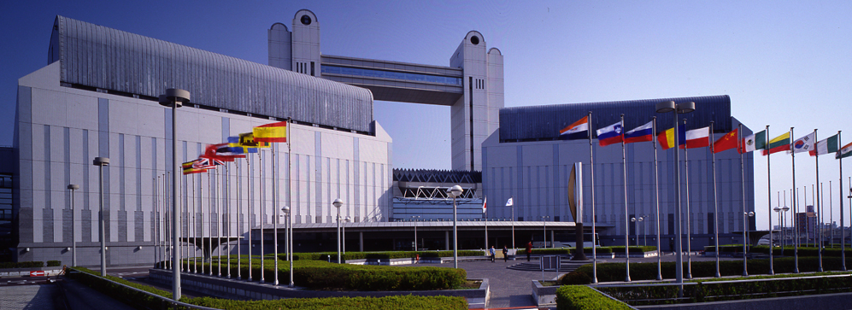
Greeting from Japanese coordinator

Dear Colleagues,

It is my great pleasure to hold the Educational Work-Shop for Young Researcher as a joint program of the 64th annual meeting of Japanese Society of Thoracic Surgery. This program is supported by JSPS’s Core-to-Core Program, Rebirth program of Deutsche Forschungsgemeinschaft (DFG), and Bilateral program of Academy of Finland (AF).
This Core-to-Core Program between Finland, Germany, and Japan, has been started since 2009. Following to the previous meetings in Vienna and Geneva, at this work-shop, I would like to exchange most recent results of our research and also clinical translational works on myocardial regeneration and cardiovascular tissue engineering, and make fruitful discussion for the further development of new technologies and methods that open the doors for completely new possibilities of patient-specific treatment.
Cardiovascular and transplant surgery has changed dramatically in the past few years. The development of new technologies and methods has enabled huge advancements that open the doors for completely new possibilities of patient-specific treatment. Cardiac tissue engineering is one of the promising fields to be developed, and is expected to produce ideal materials for cardiovascular and transplant surgery. Our core institutions have developed unique technologies in this field, and some of them have been clinically applied. In our international consortium, we will unite and integrate our technologies and produce ideal materials for supplement cardiovascular defects or support cardiac function.
I hope this work-shop makes great progresses for developing our international research consortium for myocardial regeneration and cardiac tissue engineering.

Yoshiki Sawa
Professor and Chairman
Department of Cardiovascular Surgery
Osaka University Graduate School of Medicine

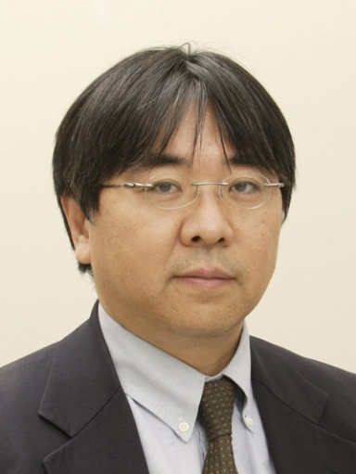
Program

Present and future scope of myocardial regeneration

Opening Remarks：9:30 - 9:35

Takayuki Kato：Japan Society for the Promotion of Science

Part 1. Invited lecture: 9:35 - 10:05

Axel Haverich: Hannover Medical School
Individualized Engineering of Cardiac Structures

Moderator: Ari Harjula：University of Helsinki

Part 2. Special lecture : 10:05 -11:05

Ken Suzuki: William-Harvey Institute, Queen Mary University
Cell Transplantation Therapy for Heart Failure

Tatsuya Shimizu: Tokyo Women’s Medical University
Cell-Sheet-Based Myocardial Tissue Engineering

Moderator: Axel Haverich: Hannover Medical School

Part 3. Lecture：11:05 -11:45

Masamichi Ono: Hannover Medical School
Development of Core-to-Core Program between Japan and Europe

Ari Harjula: University of Helsinki
The Helsinki experience on Core-to-Core program

Shigeru Miyagawa: Osaka University
From bench to bedside work in cell sheet-based myocardial regeneration therapy

Moderator: Yoshiki Sawa: Osaka University

Closing Remarks：11:45 -11:50

Yoshiki Sawa: Osaka University
Part 1. Invited Lecture

1-1. Individualized Engineering of Cardiac Structures

Axel Haverich. MD, PhD.
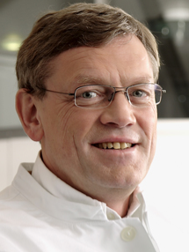
Professor and Director,
Dept. of Cardiac, Thoracic,
Transplantation, and Vascular Surgery
Hannover Medical School
Hannover, Germany

Part 2. Special Lecture

2-1. Cell Transplantation Therapy for Heart Failure

Ken Suzuki. MD, PhD.
Professor, Dept. of Translational
Cardiovascular Therapeutics
William Harvey Research Institute
Queen Mary University of London
London, UK
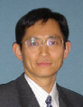

2-2. Cell-Sheet-Based Myocardial Tissue Engineering

Tatsuya Shimizu. MD, PhD.
Professor, Dept. of Regenerative Medicine
Institute of Advanced Biomedical
Engineering and Science
Tokyo Women´s Medical University
Tokyo, Japan
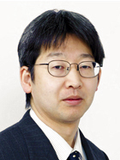
Part 3. Lecture

3-1. Development of Core-to-Core Program between Japan and Europe

Masamichi Ono. MD, PhD.
Dept. of Cardiac, Thoracic,
Transplantation, and Vascular Surgery
Hannover Medical School
Hannover, Germany

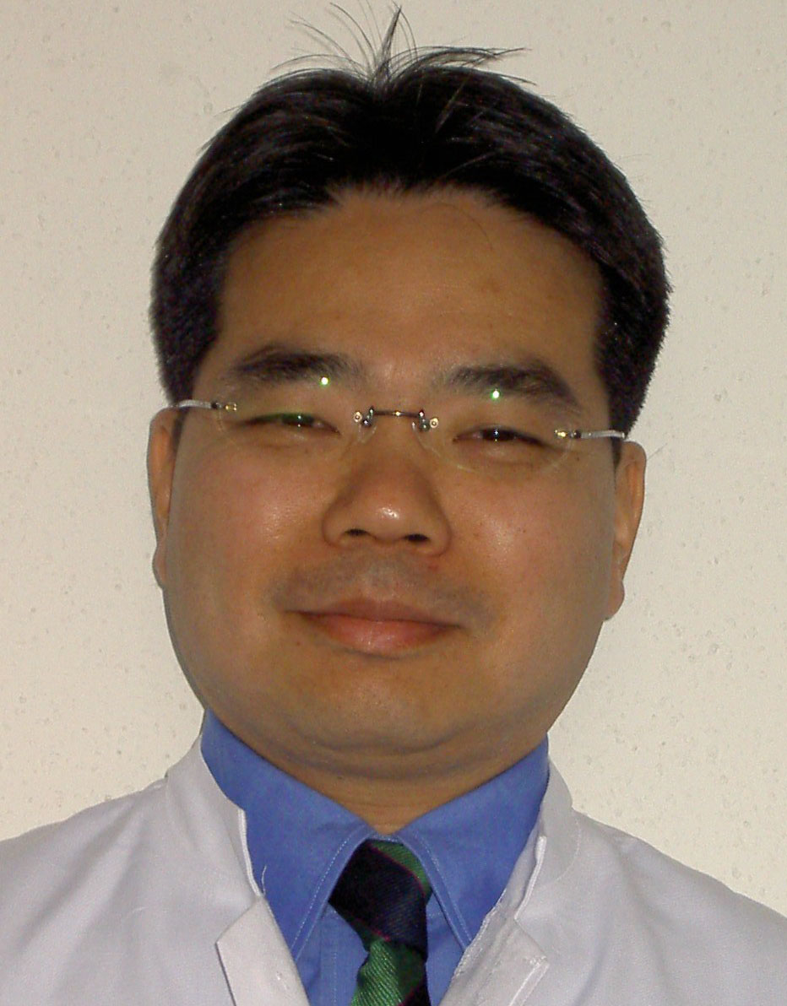

3-2. The Helsinki experience on Core-to-Core program

Ari Harjula, MD, PhD.
Professor and Director
Dept. of Cardiothoracic Surgery
University of Helsinki
Helsinki, Finland
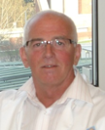

3-3. From bench to bedside work in cell sheet-based myocardial regeneration therapy

Shigeru Miyagawa. MD, PhD.
Dept. of Cardiovascular Surgery
Osaka University Graduate School of Medicine
Osaka, Japan
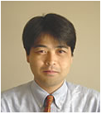

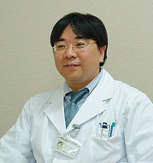
Core Institution Address

Dept. of Cardiovascular Surgery
Osaka University Graduate School of Medicine
Yamada-oka 2-2, Suita, 565 0871, Osaka, Japan
Telefon: 81-6-6879-3154
Miss. Atsuko Shimai

Dept. of Cardiac, Thoracic, Transplantation and Vascular Surgery
Hannover Medical School
Carl-Neuberg Stra.1, 30625 Hannover, Germany
Telefon: 49-511-532-9397
Masamichi Ono. MD.
E-Mail: ono.masamichi@mh-hannover.de

Dept. of Cardiothoracic Surgery
University of Helsinki, Meilahti Hospital
Haartmaninkatu 4, 00029, Helsinki, Finland
Telefon: 358-9-4717-2305
Mrs. Kaisu-Maarit Pelkonen

Please refer to the following web site

http://jsps-osaka-u.jpn.org/



